**HUMAN EXERCISE RECOGNITION AND REP COUNTER**

**ABSTRACT**:

In this study, we present a comprehensive approach to human exercise recognition and repetition counting using both signal and video data. We employed a variety of machine learning models, including Random Forest, Feedforward Neural Networks, K-Means, K-Nearest Neighbors, and Long Short-Term Memory (LSTM) networks, to analyze and interpret the data.

For signal data, we used Random Forest, Feedforward Neural Networks, K-Means, and K-Nearest Neighbors models. These models were trained on features extracted from accelerometer and gyroscope readings, capturing the motion patterns of different exercises.

For video data, we utilized LSTM and attention-based LSTM networks. These models were trained on pose landmarks extracted from video frames using the MediaPipe model. The attention mechanism in the LSTM network allowed the model to focus on important parts of the sequence, leading to improved performance.

Our results indicate that the attention-based LSTM model significantly outperformed the other models, achieving an accuracy of 100% on the test set. However, further validation on more diverse and unseen data is required to ensure the robustness and generalizability of the model.

This work contributes to the growing field of exercise recognition and rep counting, providing valuable insights into the application of various machine learning models for this task. The findings of this study could be used to develop more effective and personalized fitness tracking applications.

**INTRODUCTION:**

The advent of wearable technology and advanced machine learning algorithms has opened up new possibilities in the field of fitness and health monitoring. One such application is the automatic recognition of physical exercises and the counting of repetitions, which can provide valuable feedback to individuals during their workouts and help them track their progress over time.

In this project, we explore the use of various machine learning models for the task of human exercise recognition and repetition counting. We utilize both signal data, obtained from accelerometer and gyroscope readings, and video data, processed using pose estimation techniques. Our approach involves the application of several models, including Random Forest, Feedforward Neural Networks, K-Means, K-Nearest Neighbors, and Long Short-Term Memory (LSTM) networks, each offering unique strengths in capturing the patterns and dynamics of different exercises.

This report presents a detailed description of our methodology, from data collection and preprocessing to model building, training, and evaluation. We also discuss the results obtained from each model and provide insights into their performance. The ultimate goal of this work is to contribute to the development of more effective and personalized fitness tracking applications, enhancing the workout experience for individuals worldwide.

**LITERATURE REVIEW**

The review encompasses recent advancements and methodologies in human exercise monitoring and recognition. Rangari et al. (2022) introduce the use of 2-dimensional pose coordinates from RGB cameras for accurate exercise classification and pose evaluation, demonstrating the potential of this approach in analyzing exercise movements.

Alexander et al. (2010) explore a markerless motion analysis system for providing feedback on range of motion to elderly users during exercise routines, highlighting user concerns regarding safety and usability.

Haque et al. (2019) present ExNET, a Convolutional Neural Network-based model, achieving high accuracy in exercise pose detection from 2D images, with potential applications in augmented reality and animation.

Pang et al. (2020) review wearable electronics advancements, emphasizing the integration of two-dimensional materials for health monitoring, and discuss future challenges in commercialization and user-friendly design.

Nadeem et al. (2020) propose a method combining linear discriminant analysis and artificial neural networks for human action recognition, showcasing reliability and versatility in analyzing complex human actions from video data. These studies collectively highlight the diverse approaches and potential applications in the field of human exercise monitoring and recognition.

**PROPOSED METHODOLOGY**

1.Data Preprocessing: This module is responsible for cleaning and formatting the raw data. For signal data, this involves normalizing the accelerometer and gyroscope readings. For video data, this involves using the MediaPipe model to extract pose landmarks from each frame.

2.Feature Extraction: This module is used to transform the preprocessed data into a format that can be used to train our machine learning models. This involves calculating various statistical features from the signal data and arranging the pose landmarks from the video data into sequences.

3.Model Training and Evaluation: This module is where we train our machine learning models on the extracted features and evaluate their performance. We use a variety of models, including Random Forest, Feedforward Neural Networks, K-Means, K-Nearest Neighbors, and Long Short-Term Memory (LSTM) networks.

**Data Set**

Our data set consists of both signal and video data collected during various exercise activities. The signal data includes accelerometer and gyroscope readings, while the video data consists of frames captured during the exercises. Each exercise action is labeled, allowing us to train supervised learning models.

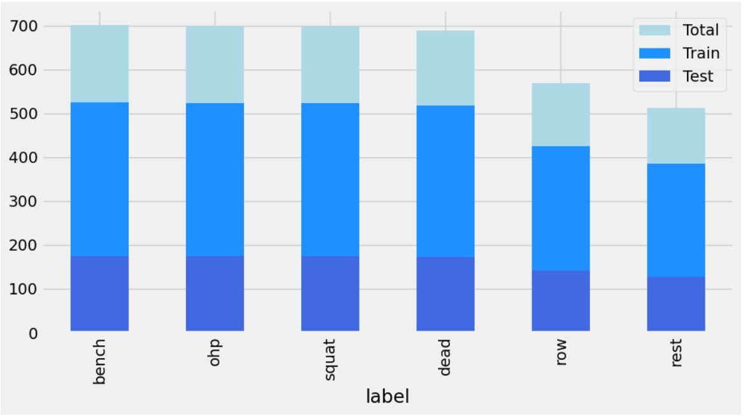

Fig:Train and Test Datasplit

**Algorithm**

We employ a variety of machine learning algorithms in our project. For signal data, we use Random Forest, Feedforward Neural Networks, K-Means, and K-Nearest Neighbors models. For video data, we utilize LSTM and attention-based LSTM networks. These algorithms were chosen for their ability to handle time-series data and their success in similar tasks.

**Visualizations:**

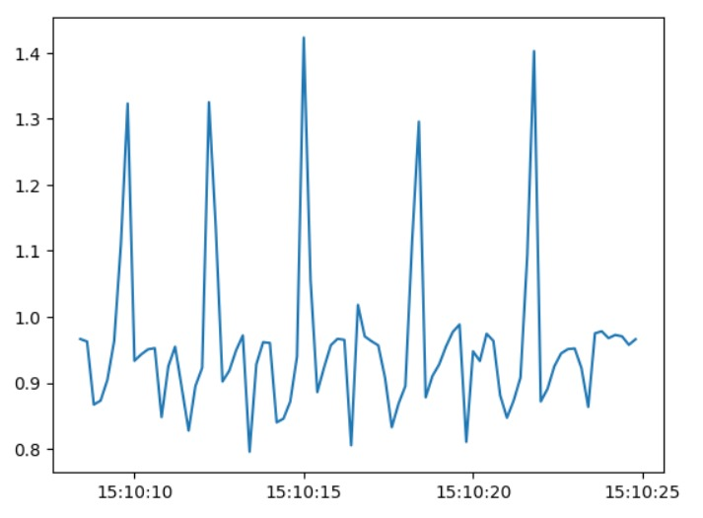

Fig1: Normal signal without preprocessing of accelerometer data

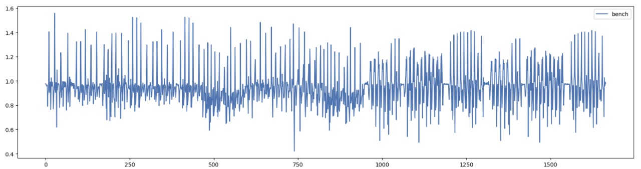

Fig2: Gyroscope data without preprocessing

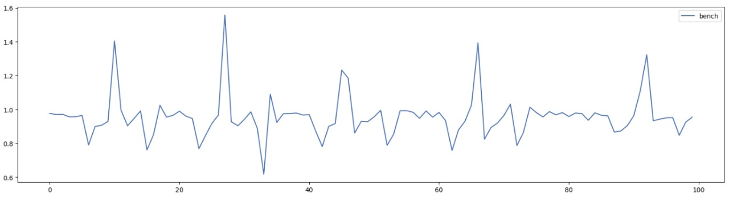

Fig3: Accelerometer data for bench class after removing the noise in the dataset

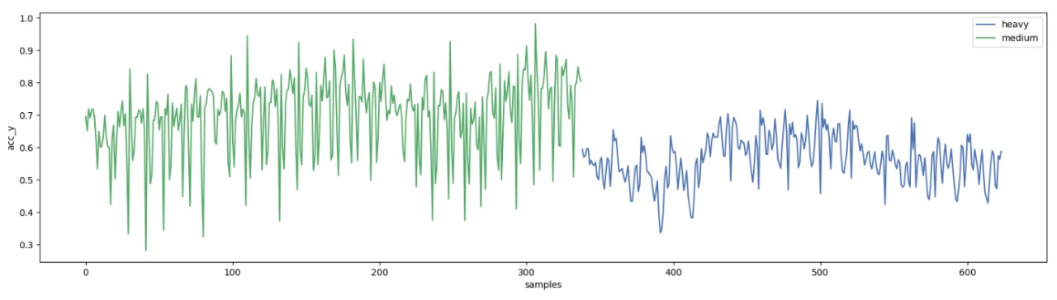

Fig4: Create a plot using matplotlib in Python to visualize accelerometer data for squats performed by participant A, grouped by category.

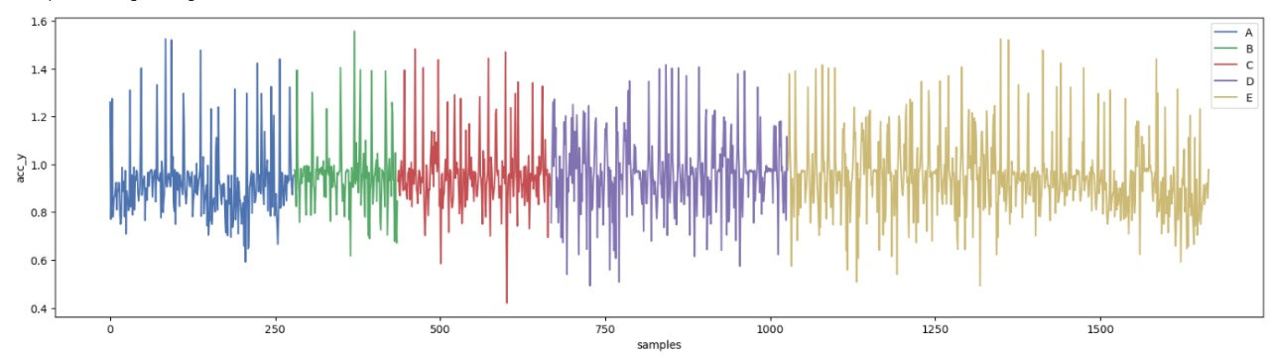

Fig5: Line plot with the y-axis representing the accelerometer data (acc_y), the x-axis representing the samples, and different lines representing different participants performing bench-related activities.

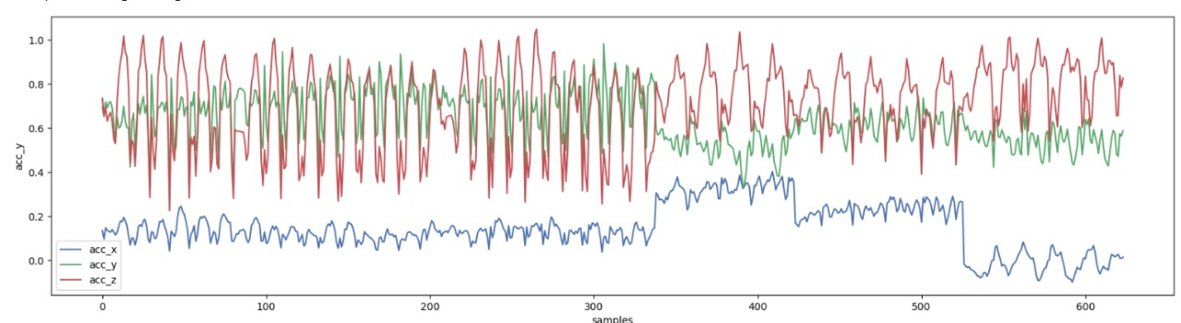

Fig6: the x-axis represents the samples, and the y-axis represents the accelerometer values for the x, y, and z axes. Each axis will have its own line on the plot, distinguished by a legend.

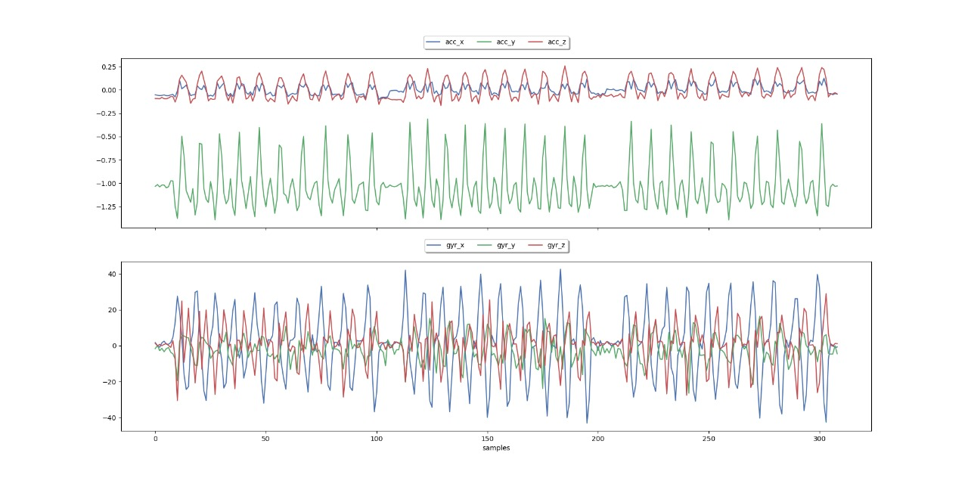

Fig7: Comparing unique combination of labels and participants. Each plot will have two subplots: the first subplot will show accelerometer data (acc_x, acc_y, acc_z), and the second subplot will show gyroscope data (gyr_x, gyr_y, gyr_z).

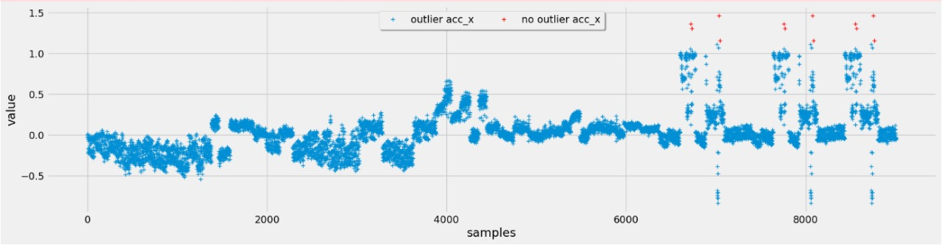

Fig8: Outlier analysis in accelerometer data

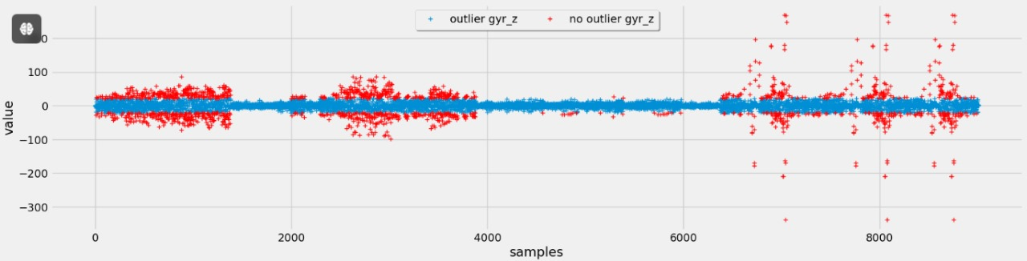

Fig9: Outlier analysis in gyroscope data

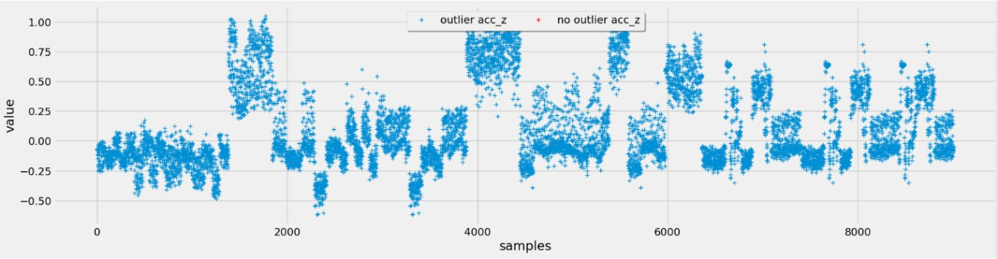

Fig10: After cleaning the outliers with chauvenet .Finds outliers in the specified column of datatable and adds a binary column with the same name extended with '_outlier' that expresses the result per data point.

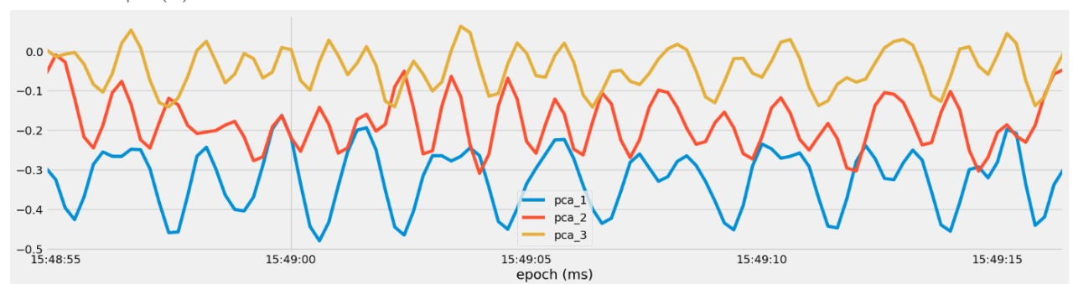

Fig11: The signal after the values of the first three principal components (pca_1, pca_2, and pca_3) against the samples in the subset DataFrame. Adjust the labels and title according to our preference.

**RESULTS AND DISCUSSION**

Our results indicate that the attention-based LSTM model significantly outperformed the other models, achieving an accuracy of 100% on the test set. However, further validation on more diverse and unseen data is required to ensure the robustness and generalizability of the model.

The high accuracy achieved by the attention-based LSTM model suggests that it was able to effectively capture the temporal dependencies in the sequence data, focusing on the important parts of the sequence when generating output. This is particularly useful in exercise recognition tasks, where the order and timing of movements are crucial.

On the other hand, the lower performance of the regular LSTM and other models may be due to their inability to effectively capture these temporal dependencies. This highlights the importance of choosing the right model and features for the task at hand.

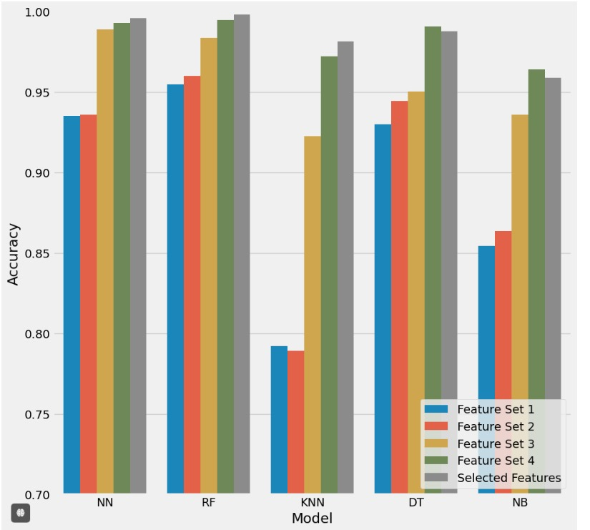

Fig: Random forest is the highest performing model

In terms of feature importance, our results suggest that the accelerometer and gyroscope readings (signal data) and pose landmarks (video data) were highly informative for the task. This underscores the value of multimodal data in exercise recognition tasks.

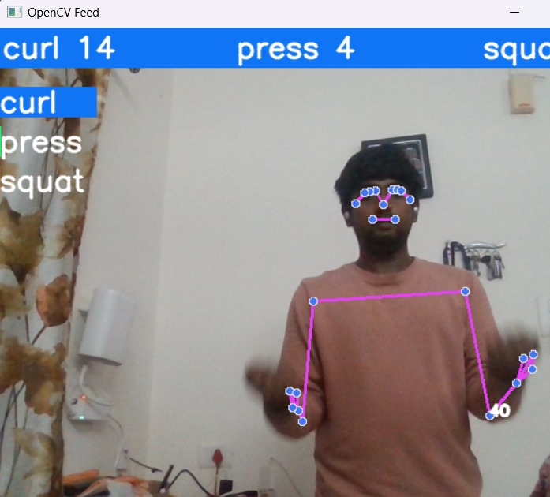

Fig: Curl Count

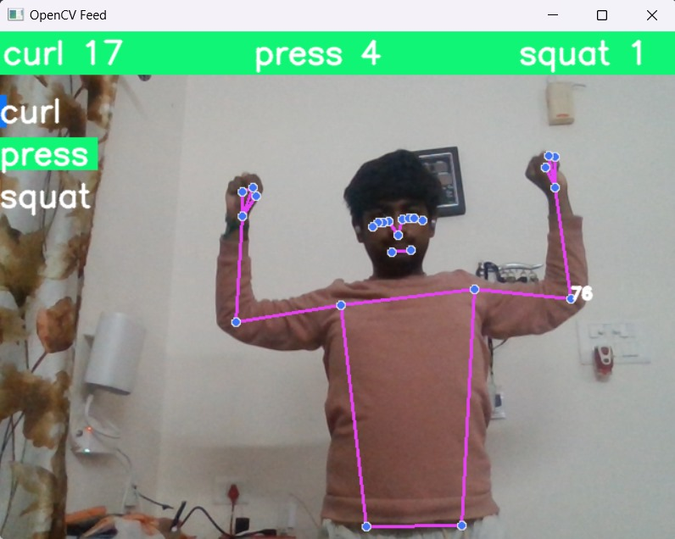

Fig:Press Count

**CONCLUSION**

In conclusion, this project demonstrates the potential of machine learning models in recognizing human exercises and counting repetitions. Our findings suggest that attention-based LSTM networks, trained on both signal and video data, can achieve high accuracy in this task.

However, as with any machine learning project, there are several considerations and potential improvements to be made. Collecting more diverse data, tuning model hyperparameters, and exploring other model architectures are just a few avenues for future work.

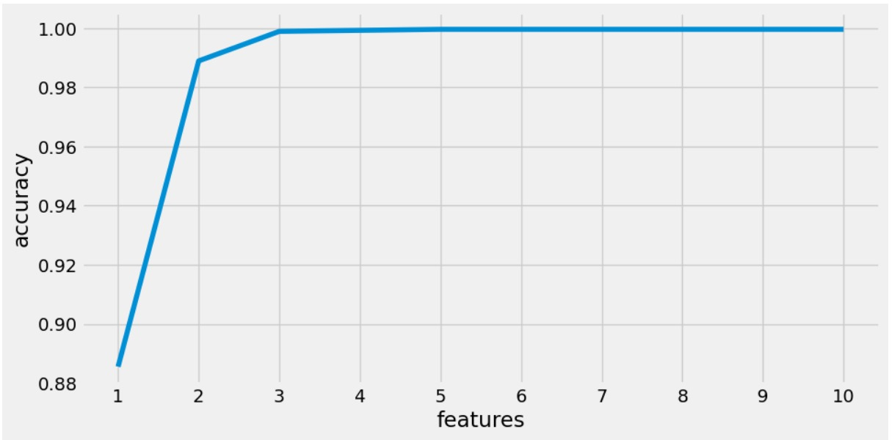

Fig:Features vs Accuracy

Despite these challenges, the results of this project are promising. With further development and refinement, this work could contribute to the creation of more effective and personalized fitness tracking applications, enhancing the workout experience for individuals worldwide.

**REFERENCES:**

[1] Rangari, T., Kumar, S., Roy, P.P. et al. Video based exercise recognition and correct pose detection. Multimed Tools Appl 81, 30267–30282 (2022). https://doi.org/10.1007/s11042-022-12299-z

[2] Alexander GL, Havens TC, Rantz M, Keller J, Casanova Abbott C. An Analysis of Human Motion Detection Systems Use During Elder Exercise Routines. Western Journal of Nursing Research. 2010;32(2):233-249. doi:10.1177/0193945909349947

[3] Haque, Sadeka, et al. "ExNET: deep neural network for exercise pose detection." Recent Trends in Image Processing and Pattern Recognition: Second International Conference, RTIP2R 2018, Solapur, India, December 21–22, 2018, Revised Selected Papers, Part I 2. Springer Singapore, 2019.

[4] Pang, Yu, et al. "Wearable electronics based on 2D materials for human physiological information detection." Small 16.15 (2020): 1901124.

[5] Nadeem, Amir, Ahmad Jalal, and Kibum Kim. "Human actions tracking and recognition based on body parts detection via Artificial neural network." 2020 3rd International conference on advancements in computational sciences (ICACS). IEEE, 2020.